Республиканская олимпиада «Эрудит»
по английскому языку для школьников 2-6 классов 4 класс

2023 год

- Прочитай слова. В каждой строчке найди и подчеркни слово, которое отличается гласным звуком.

1. light smile soap cry fly
2. blue tune boot sky mute
3. make late fan cake pale
4. meet sleep head speak tea
5. but must plus jump cute

- Разгадай кроссворд.
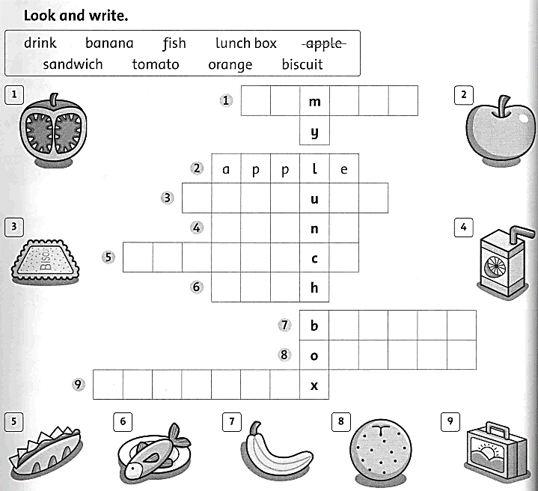

- Прочитай письмо.

Hi! My name is Kelly. I live near London in a big city. Downstairs, there is a hall, a toilet, a dining room and a kitchen. The kitchen is next to the toilet. Upstairs, there are two bedrooms, a bathroom and a study. Outside the house, there is the garden, where my father puts the family car. There is a small garden in front of the house, where I play with my friend Kamel. My bedroom is very beautiful. I’m very proud of it. It’s ten o’clock p.m. Time for bed.
Bye!
- Обведи в кружок правильный ответ.
a) Kate, a girl from Australia.
b) Kelly, a girl from London.
c) Kamel, a boy from Egypt.

- Вставь артикль а, где нужно.

1. It is … girl.
2. It is … yellow banana.
3. It is … white.
4. This is … my book.
5. This is … lion.
6. They are … dogs.
7. It is … big.
8. It is … red pencil.
9. It is … cat.
10. It is … funny.

- Вставь в пропуски слова “than”, “of” или “in”.

- My room is larger _______yours.
- The white car is the fastest _______the three cars.
- Watching TV is more interesting ________listening to the radio.
- He is the best student ________his class.
- She has got the most money _______all.
- I’ve got more money ________you.
- Summer is hotter ________winter.
- Tom is the oldest ________all.
- Winter is the coldest month ________the year.
- The red dress is the most beautiful _______all.

- Прочитай названия стран и допиши национальности.

- The USA - _________________
- New Zealand -__________________
- Britain - ______________________
- Brazil - ______________________
- Australia - ______________________
- China -__________________
- Russia - _________________
- Germany - ________________
- Italy - ______________________
- Spain -___________________
- Найди и выдели десять слов, обозначающих предметы, животных и людей на картинках.
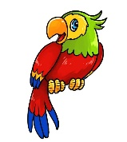

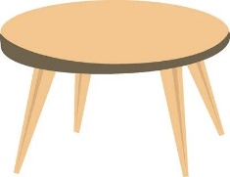
i | k | x | c | l | o | c | k | o | e
b | c | f | l | o | w | e | r | y | j
m | s | g | h | c | o | a | t | r | w
d | s | o | f | a | u | q | z | n | s
l | u | m | b | r | e | l | l | a | b
r | f | a | m | i | l | y | w | h | k
a | s | e | l | e | p | h | a | n | t
b | o | n | i | o | n | f | m | a | k
r | b | q | p | a | r | r | o | t | y
t | a | b | l | e | d | f | n | i | m
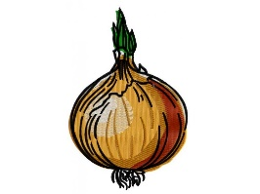

- Cоставьте словосочетания и запишите их в третьем столбике. Каждое слово используется только один раз.

1. walk | A. music
2. listen to | B. a tree
3. paint | C. the dog
4. visit | D. a picture
5. go | E. a friend
6. climb | F. to the seaside

- Ответьте на забавные вопросы, запишите ответы по образцу.

0. The first day of the week is Sunday.
1. The last day of the week is __________.
2. You drink it when you are very thirsty. _____________.
3. The first month of the year. _____________.
4. The month that follows October. _____________.
5. A domestic animal that can bark. ________.
6. A very big animal. _____________.
7. Eight plus one is ______________.
8. Your mother and father are your ______________.
9. What language do people speak in England? ______________.
10. What language do people speak in Russia? _______________.

10. Пользуясь подсказкой, напишите предложения о себе.
1.can’t, well, drive, I.__________________________________________
2. like, songs, to, I, new, to, listen.__________________________________
3. can, English, friend, speak, My.__________________________________
4. I, old, hate, computers._________________________________________

11. Подберите для каждого урока соответствующие учебные принадлежности.
Запишите ответы в таблице.

1. Atlas | a) English
2. Paints | b) Maths
3. Experiment | c) Geography
4. Dictionary | d) Music
5. Calculator | e) Science
6. Piano | f) Art

1 | 2 | 3 | 4 | 5 | 6

