Республиканская олимпиада «Эрудит»
по английскому языку для школьников 2-6 классов 3 класс

2023 год

- Прочитай текст и заполни пропуски.
I have a pet cat. His name is Stripes. He is seven. Stripes has a fat body and a long tail. His eyes are blue. My cat is very funny. He likes jumping and playing. He can climb, too! I love Stripes.

1. Stripes is……..
a) my cat b) my parrot c) my dog
2. He has got a long ………...
a) body b) tail c) neck
3. He likes …….
a) swimming b) running c) jumping
4. He can………...
a) fly b) climb c) dance
- Вычеркните лишнее слово в каждой строчке.
1) cheese, bread, eyes, coffee
2) cat, zebra, tiger, elephant
3) funny, clever, small, body
4) orange, potato, tomato, onion
5) chair, sofa, pen, bookcase
6) meat, dream, read, head
7) yellow, blue, brown, big
8) friend, mother, brother, sister
9) skirt, jeans, mouth, shorts
10) run, sing, play, horse
- Какие из этих слов обозначают части тела? Подчеркните их.
head - apple - nose - eyes - bread - ears - neck - hand

- Внимательно посмотрите на картинку и прочитайте предложения. Скажите соответствуют ли эти предложения картинкe? Обведите в кружок ДА или НЕТ.

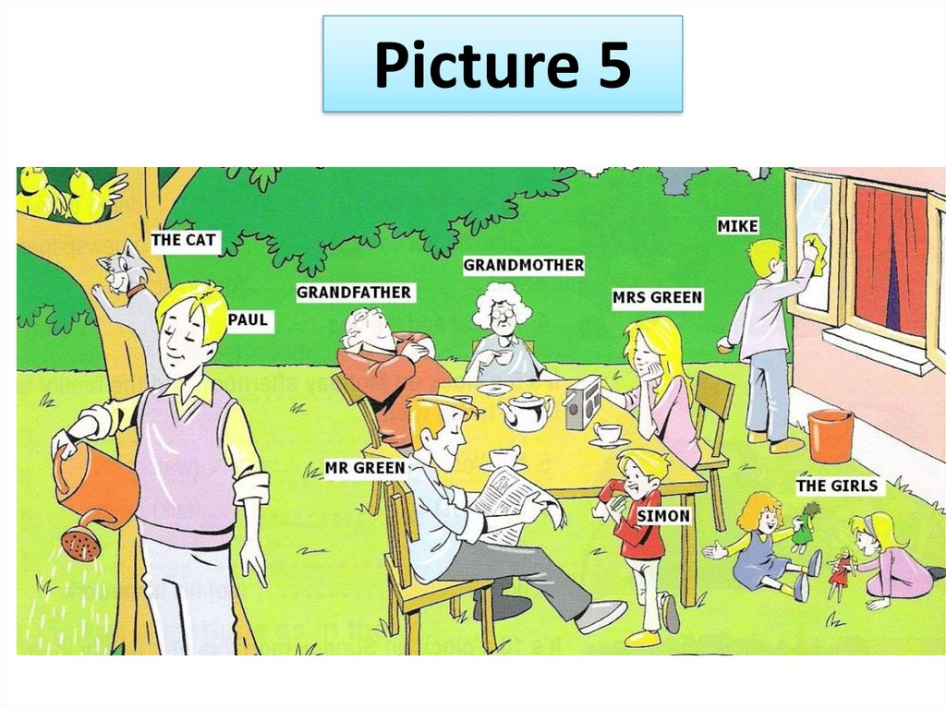

1. The cat is climbing the tree. Да / Нет
2. Mr. Green is riding a bike. Да / Нет
3. Paul is reading a book. Да / Нет
4. The girls are playing. Да / Нет
5. Mrs. Green is listening to the radio. Да / Нет
6. Mike is eating an apple. Да / Нет
- Поставьте существительное во множественное число там, где нужно.
1) two/monkey – _____________________________________
2) four/mouse – ______________________________________
3) one/boy – _________________________________________
4) ten/book – ________________________________________
5) one/bag – _________________________________________
6) twelve/tooth – _____________________________________
7) three/woman - _____________________________________
8) nine/baby – _______________________________________
9) six/apple – ________________________________________
10) fourteen/box – ____________________________________
- Какое слово не сочетается с остальными? Вычеркните лишнее слово.
shirt - T-shirt - trousers - banana - shoes - tights - tie – socks

- Составьте предложения из данных слов.
1) run, can, fast, She, very

______________________________________________

2) blue, Mike, got, has, eyes

_______________________________________________

3) tails, got, long, have, Lions

________________________________________________

4) like, I, books, reading

_________________________________________________
5) very, My, friendly, mother, is

_________________________________________________

6) the, We, in, are, kitchen

_________________________________________________
- Отгадайте животных и напиши их название.
1) I live in water. I can swim very well. Cats like to eat me. ______________
2) I am very big. I am grey. My nose is very long. _______________
3) I can climb. I like to eat bananas. __________________
4) I am green. I can jump. I can swim. ________________
5) I am very small. I like to eat cheese. ______________
- Опишите себя, используя текст.
Victoria | Me
Hi! My name is Victoria I am 10
years old. I am from Liverpool,
England. I was born in October.
My favourite school subjects are
Music, Physical Education, English
and Art. I like playing computer
games. I dislike doing my homework.
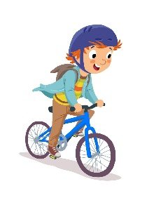
- Соедините слова и фразы с картинками.
с

a

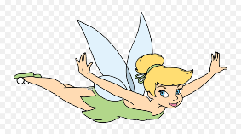
1) ride a bike
f

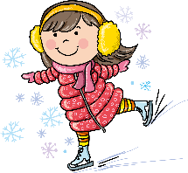
2) skate
d

3) play tennis
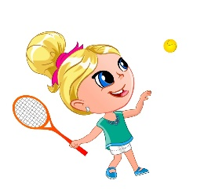
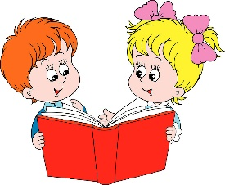
4) sail
b

5) read a book
g

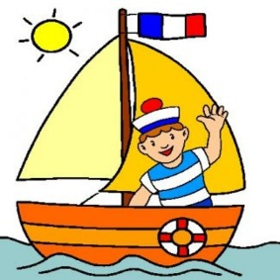
6) drive a car
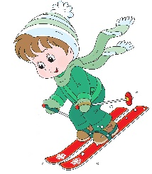
7) ski
е

8) fly
h

